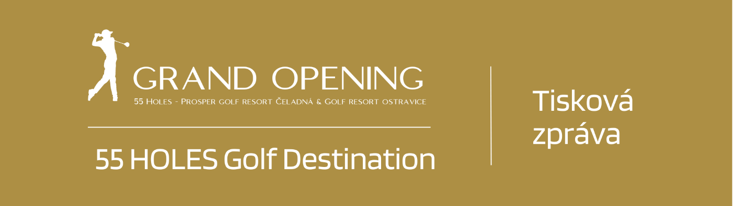

**Connecting two attractive golf resorts in the foothills of the Beskid Mountains creates the largest golf destination in the Czech Republic.**

**Čaladná / Ostracice 21.3.2024**

**55 HOLES GOLF DESTINATION** is the result of connecting two exceptional golf resorts in the attractive environment of the Beskids – **Prosper Golf Resort Čeladná** and **Golf & Ski Resort Ostravice**. It becomes the **largest golf destination in the Czech Republic** and offers golfing, accommodation and other destination services of exceptional quality and, above all, under better conditions. Guests of our golf destination have access to three 18-hole championship courses surrounded by the picturesque nature of the Beskid Mountains, 2 restaurants, 3 hotels, 2 conference halls for social events and conferences, wellness facilities and 2 golf academies. Starting from the new season, there will be a significant change in our golf academies. They will now be led by **Spanish coach Gonzalo Sánchez**, a world-class PGA Golf Professional accredited coach and an authorised instructor of the **worldwide Stack and Tilt golf academy**. However, the philosophy of our academies remains the same; we focus on children, beginner players, amateurs and also professionals.

***Jan Kastner, General Manager of Prosper Golf Resort Čeladná:***

*We are delighted that after many years, we can take advantage of the unique situation where two of the most significant golf resorts in the Czech Republic are close. By combining them into joint products and services, we can create a truly significant golf destination here. And thanks to our new addition – Spanish coach Gonzalo Sánchez, we have an international touch right from the start, which is great. There are even more innovations as Prosper Golf Resort Čeladná has undergone extensive reconstruction and is prepared for the new season in a better condition, not only technically but also in terms of the services that it offers to golfers and other guests.*

***Slavomír Dufek, Manager Golf & Ski Resort Ostravice:***

*We are pleased to expand the portfolio of services for visitors of both resorts. The resorts already cooperated in the past and now the range of services is expanding, allowing clients or visitors to choose the very best.*

**North Moravia and Silesia** are regions that combine history, culture, industrial heritage and beautiful nature. This place offers many opportunities for tourists to explore the rich cultural heritage and enjoy the natural beauty of the Moravian-Silesian region. Ostrava is a city of culture and sports, regularly hosting the largest events in the Czech Republic. **7 golf resorts are an integral part of the Moravian-Silesian region, making is the second-largest golf region in the Czech Republic after the Central Bohemian Region.**

**One of the goals of 55 HOLES Golf Destination is to increase the attractiveness of the Moravian-Silesian Region** not only for Czech golf players and tourists but also to attract foreign clientele and raise awareness of our region in foreign markets. And this is where our excellent cooperation with the Moravian**-Silesian region, the Northern Moravia Destination and CzechTourism** helps us a lot. Together, we are creating a communication campaign focused on supporting the visibility of the region and tourism.

***Petr Koudela, executive director of the Moravian-Silesian Tourism, s.r.o. company:***

*Golf is one of the key pillars of tourism in our region. We certainly welcome the fact that the region will boast the largest golf destination in the Czech Republic. The connection of the golf courses is an important step in tourism that will help improve the image of our Northern Moravia as a tourist destination. I believe that this significant investment in golf infrastructure will attract more visitors to our region and strengthen not only our position on the map of golf destinations but also the awareness of Northern Moravia as a great holiday destination with a rich network of services and quality leisure activity facilities.*

**The season opening and Grand Opening 2024 of 55 HOLES Golf Destination is scheduled for 18th and 19th April 2024. In addition, the partnership of the attractive 55 HOLES Golf Destination with top motorsport represented by Effective Racing, a Czech Formula 3 team, and its pilot Vladimír Netušil, is going to be presented at the opening.** This partnership will not only provide our clients, members and partners with social contacts and the opportunity to peek behind the scenes of big races and into the secrets of golf but also offer new business opportunities. **The event is going to include charitable activities in cooperation with the EGO Foundation and the proceeds will be subsequently donated to the Children's Home in Čeladná.**

***Vladimír Netušil, Effective Racing pilot, Czech Formula 3 team:***

*It is a great honour for me to be part of this innovative cooperation that combines the world of motorsport with an exclusive golf destination. The opening of 55 HOLES Golf Destination is not only an exciting golf event of the year but also the beginning of a new era where passion, precision and strategy come together. The partnership between Effective Racing, the Enter Business Club and 55 HOLES Golf Destination opens up not only completely new opportunities for our clients and partners in both industries but also broadens the horizons of business. Together, we create an environment for synergy that provides a platform for new business opportunities and social contacts. We are pleased to contribute to the development of this beautiful region and to support charitable activities that help where it is most needed.*

***Mgr. Veronika Janečková, Director of the Product Management Department, Czech tourism head office – CzechTourism:****Active holidays are becoming increasingly popular with tourists and golf is definitely among the top choices. In the context of the Czech Republic's offer for golfers, the unique combination of beautiful nature, cultural monuments and other leisure opportunities stands out. To put it simply, families can come together to the Czech Republic, even to Northern Moravia, and everyone will find something for themselves. 55 Holes Golf Destination is unique not only in terms of its size but also due to its services, the untouched nature of the Beskid Mountains and the abundance of attractions in the immediate vicinity, such as traditional culture in Rožnov pod Radhoštěm but also the modern face of Ostrava*.

**The opening of 55 HOLES Golf Destination should be the golf event of the year. We are proud to help create this project and have the opportunity to launch a new era of golf sport in the Moravian-Silesian region and the Czech Republic. 55 HOLES Golf Destination. Enjoy not only golf in the heart of the Beskid Mountains!**