**PRESS TRIP – Colours of Ostrava** **2022**

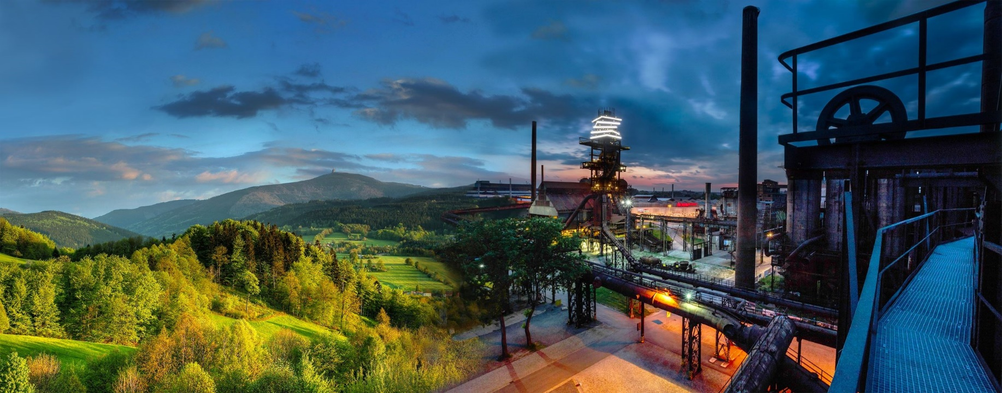**July 13 – July 16 2022 (Wednesday-Sunday)**

**Wednesday, July 13**

* arrival to Ostrava Main Railway Station, transport to the hotel – Harmony hotel Ostrava (taxi or pick up based on previous agreement).
* 12.30 pick-up from the hotel
* 13:00 welcome snack and drink in the park (Komenského sady)
* 14.00 Trip to Ema (heap formed from extracted mining waste & emits hot gases
* 16.00 transfer to Colours of Ostrava (accreditation)
* Free entertainment

**Thursday, July 14**

* 9:30 pick-up from the hotel
* Trip to Pustevny (mountain range in Beskydy mountains, approx. 45 min driving distance)
  + Cable lift ride to the top of the hill/hiking option (35 minutes uphill)
  + Visit to “Stezka Valaška” – wooden view tower
  + Lunch in Libušín (historical cottage)
  + Ride on footbike/cable lift/downhill hike back to parking lot
* 14.30 arrival to Ostrava
* 16.00 pick-up from the hotel – transfer to Colours of Ostrava
* 19.00 Cokafe – Pojez project – introduction of gastro project, snacks &drinks

**Friday, July 15**

* 10:00 pick up from the hotel
* [Štramberk](https://mamesvetovykraj.cz/en/stramberk-town/) - a picturesque town at the foot of the Beskydy Mountains, where ears are baked
* Museum of TATRA Trucks in Kopřivnice – opened in November 2021
* Lunch
* Return to the hotel in Ostrava
* 16.00 pick-up from the hotel – transfer to Colours of Ostrava
* 19.00 Tour to Bolt Tower (visit to Bolt Café – snack, drinks, coffee)
* Free entertainment

**Saturday, July 16**

* 10:30 pick up from the hotel
* Ostrava tour on bikes
* Lunch
* 15:00 pick-up from the hotel – transfer to Colours of Ostrava
* Free entertainment

**Sunday, July 17**

* individual departure

Our websites:

[www.northmoravia.travel](http://www.northmoravia.travel)

[www.ourworldlyregion.com](http://www.ourworldlyregion.com)

Our socials:

FB: @northmoravia ([(1) Severní Morava a Slezsko | Facebook](https://www.facebook.com/northmoravia))

IG: [Severní Morava a Slezsko (@severnimorava_slezsko) • Fotky a videa na Instagramu](https://www.instagram.com/severnimorava_slezsko/)