

Czechia Travel Trade Day

North Moravia
Location Tour in Ostrava

Program: April 29th, 2025

Tuesday Ostrava

Option 1 (Architecture)

09:30 Departure from Clarion Congress Hotel Ostrava
10:00 Short guided tour of the communist architecture of ´50s
11:00 Guided tour: Villa Grossmann
12:00 Transfer back to the hotel

Option 2 (Bike tour: in case of good weather conditions)

09:30 Departure from Clarion Congress Hotel Ostrava
10:00 Guided bike tour: Ostrava City Centre (up to 10 km)
12:00 Transfer back to the hotel

Option 2 (MICE: in case of bad weather conditions)

09:30 Departure from Clarion Congress Hotel Ostrava
10:00 Short guided tour: Quality hotel Ostrava City and MERCURE Hotel City
11:00 Short guided tour: wine cellar Ostrava
12:00 Transfer back to the hotel

Option 3 (Industrial)

09:30 Departure from Clarion Congress Hotel Ostrava
10:00 Experience: U6 / Dolní Vítkovice
11:00 Short hike: Ema Heap (In case of bad weather conditions
Guided tour: FUTUREUM / Dolní Vítkovice)
12:00 Transfer back to the hotel

In cooperation with:

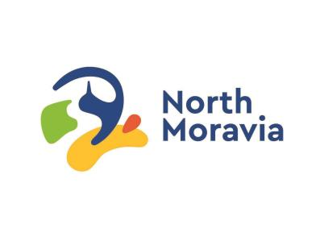
www.northmoravia.travel
www.ourworldlyregion.com
FB: Severní Morava a Slezsko, @northmoravia
IG: Severní Morava a Slezsko (@severnimorava_slezsko)
Technical attractions: @technotrasa
Food experience: @pojez.fest, @pojez

