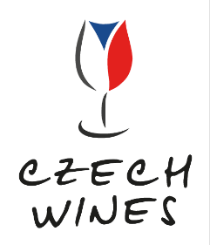
Press Release
Czech National Wine Centre Invites You to Discover the Vibrant World of local Winemaking at ProWein 2025
The Czech National Wine Centre is delighted to welcome you to a vibrant mosaic of Czech winemaking at ProWein 2025. Our stand will feature 10 diverse wineries, showcasing almost 60 samples presented by the winemakers themselves, along with more than 100 additional samples available in our free tasting zone. These wineries represent a dynamic range of proactive and export-oriented companies, from small boutique wineries to some of the largest producers in the Czech Republic.
Returning with its iconic sleek and contemporary design, our stand at ProWein 2025 invites visitors to explore the rich diversity of Czech winemaking in a sophisticated and welcoming setting. The open layout and inviting ambiance make our stand a captivating focal point amidst the bustling exhibition atmosphere.
This year we are presenting new motto “Czech wines of the Future”, reflecting the huge potential we have in our region: new generation of winemakers, great vineyard sites yet undiscovered with cool climate influence and respect for environment. Winemaking is reacting to all contemporary challenges and new generation is accepting the responsibility for the impact on future therefore the soil health and balance is crucial. With our location in the centre of Europe our position in the global market can be rising, as consumers all around the world are seeking for new taste experiences and terroirs.
Highlights of Our Presentation
Local Darlings: Discover familiar varieties like Grüner Veltliners, Blaufränkisch, and Welschrieslings, and experience their unique expressions in Czechia. Meet local favorites such as Pálava (white and aromatic) and Müller-Thurgau (fresh and fruity white), which are distinctive to our region.
The Internationals: Taste internationally renowned varieties with Czech roots, known for their solid acidity, spiciness, and fruitiness. Sample exceptional Rieslings, Sauvignon Blancs, Chardonnays, and both Pinot Blanc and Noir.
Bubbles & Natural & PiWi: Embrace the global trend of ecological farming, organic and low-intervention wines with our PiWi´s and even DEMETER samples and other natural wines.
Special Events
Join us in Hall 9 at Booth H89, designed by CHYBIK + KRISTOF ASSOCIATED ARCHITECTS, where circles and rounded shapes symbolize the essence of winemaking. Meet the winners and finalists of prestigious competitions such as Winery and Winemaker of the Year and the Czech National Competition, as well as successful exporters to countries including Japan, the UK, Sweden, the US, and Canada.
Sunday at 2 PM: Taste a unique selection of Magnum bottles with Klára Kollárová, national sommelier and DipWSET.
Monday at 2 PM: Klára Kollárová will present older vintages, showcasing the high quality and aging potential of Czech wines.
What Makes Czech Wines Special?
Moravian and Bohemian white wines are renowned for their fascinating spectrum of aromas, rich extractive substances, and harmonious combination of full-bodied flavours with fresh, vibrant acidity. Recently, Czech red wines have gained recognition for their full-bodied, expressive, yet soft and velvety character with a pleasant fruity aroma.
About Czech National Wine Centre
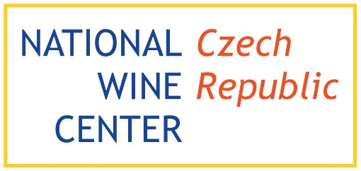
The Czech National Wine Centre is a non-profit organization dedicated to promoting and supporting Czech wines and winemaking. We are national coordinator for worldwide Wine in moderation movement. We organize and support competitions, maintain the Wine Salon tasting exhibition, host workshops, seminars and other formats to educate the whole sector.

We look forward to welcoming you to our stand at ProWein 2025 and sharing the unique and diverse world of Czech winemaking with you.
Visit our Exhibitor profile and our Free Tasting Zone profile



Dagmar Fialová, Marketing & Export Director
+420 720 820 921 | dagmar.fialova@vinarskecentrum.cz
Klára Kollárová, National ​s​ommelier
DipWSET & Fine and Rare Wine Specialist & The Weinakademiker
+420 603 116 085 | klara.kollarova@vinarskecentrum.cz|
www.vinarskecentrum.cz | www.salonvin.cz | www.facebook.com/NVC.SalonVin

