The international gastronomic guide Gault&Millau has evaluated restaurants in Czechia for the second time. The number of four-toque restaurants has increased.

26. 1. 2026
More award-winning restaurants than last year, new trophies for gastronomic personalities, and the presentation of the Stay & Dine "hotel" guide. On Monday, January 26, the gala evening of the international gastronomic guide Gault&Millau, held at the National House in Vinohrady, brought not only the expected launch of the 2026 edition, but also a number of innovations.
The second edition of the Gault&Millau gastronomic guide for Czechia includes a total of 421 rated restaurants. Of these, 334 managed to achieve a rating of at least 11 points out of a total of 20, thanks to which they can boast the prestigious symbol of a chef's toque. The authors also included 146 establishments in the POP category in the guide. Although these are not rated by inspectors, the guide mentions them as interesting places to visit.
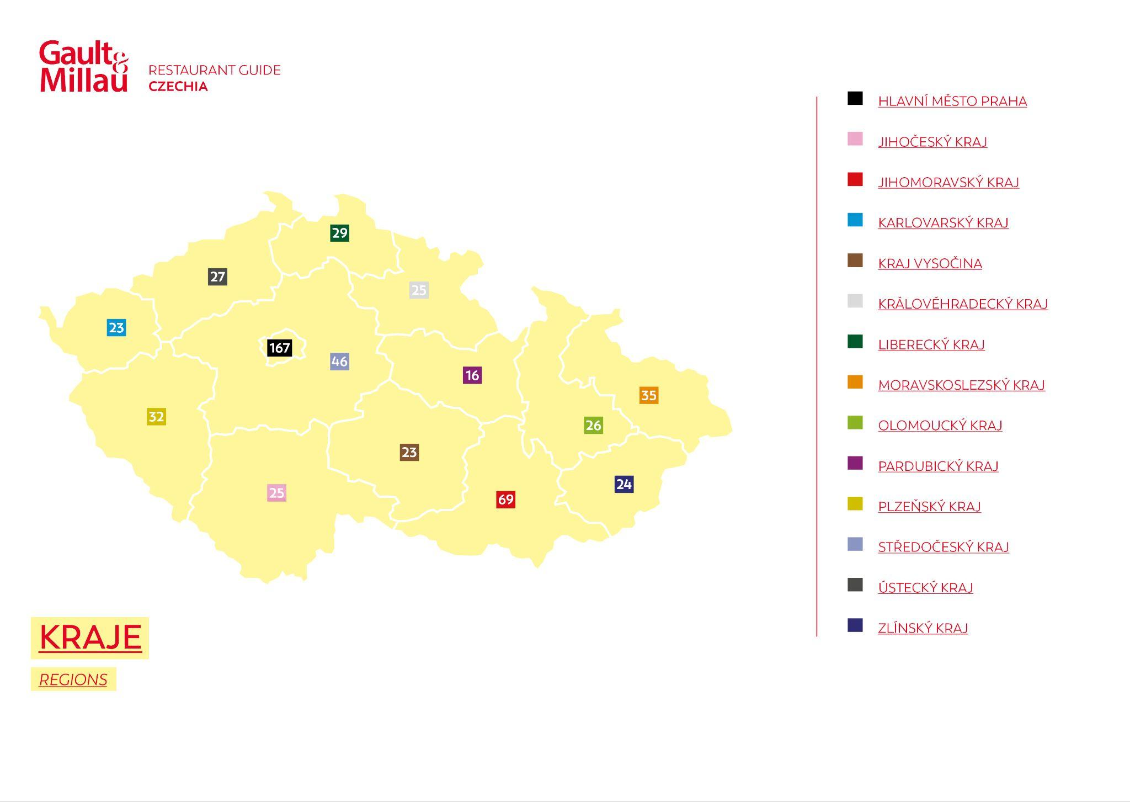
Once again this year, no Czech restaurant achieved the highest possible rating of five toques. However, three establishments received four toques – in addition to last year's four-toque "only child," the Restaurant Papilio, this time it was also LEVITATE and La Degustation Bohême Bourgeoise.
There were 17 restaurants awarded three toques: Restaurant Essens, Štangl, Salabka, TARO, Dejvická 34 by Tomáš Černý, STŮL, Zlatá Praha, 420 Restaurant, Augustine Restaurant, Borgo Agnese, Field Restaurant, La Finestra in Cucina, Mlýnec, Monastiq Restaurant, Pot au Feu, Terasa U Zlaté studně, and TRITON Restaurant.
"In the past year, the inspectors had to re-evaluate establishments from the previous edition, as well as a number of new ones that they had not had time to visit yet or that had just opened and caught our interest. The overall figures and the number of new restaurants in the highest tiers clearly show that Czech gastronomy really has something to offer guests from both home and abroad. In our work, we can clearly see that our establishments and Chefs are beginning to attract attention from abroad in various forms, which is great," said Miroslav Lekeš, Gault&Millau's Chief Inspector for Czechia and CEO of Gault&Millau for Czechia, Slovakia, Hungary, and Italy, commenting on this year's edition of the gastronomic guide.
At the gala evening, the organizers from Gault&Millau presented trophies to exceptional personalities and businesses in Czech gastronomy in eight categories. Oldřich Sahajdák, Chef Patron of the La Degustation Bohême Bourgeoise restaurant, was named the Chef of the Year 2026. Khanh Ta (TARO) was awarded the Great Chef of Tomorrow, Jan Horák (Reason) became the Young Talent of the Year, Sabina Keltnerová (Štangl) was named the Pastry Chef of the Year, Vít Eliáš (Zlatá Praha) was awarded the Sommelier of the Year, Jiří Hrachový (Výčep) was named the Chef of Traditional Cuisine, the bistro and café DOK in Liberec won the title POP of the Year and the Fairmont Golden Prague was awarded the Gourmet Hotel of the Year.
These awards are a prestigious recognition of the work of these gastronomic professionals. "It is an expression of trust, professional attention, and respect, which is extremely valuable in our field. At the same time, it is a powerful moment for the entire team, because gastronomy is a collective discipline. The entire year after winning the Chef of the Year title brought professional advancement and a higher level of responsibility. It meant an even stronger emphasis on detail, stability, and team growth. It opened the door to new collaborations, talents, and guest expectations. I consider the motivation of myself and the entire team to push the boundaries of what modern Czech cuisine can offer to be of the highest value," said Jan Knedla from the Restaurant Papilio, assessing the benefits of his Gault&Millau Chef of the Year 2025 award last year.
The general partner of the Gault&Millau guide in Czechia is MAKRO Cash & Carry ČR. "The number of establishments awarded in the Gault&Millau guide confirms that Czech gastronomy has reached a high level and is able to maintain it in the long term. This year's results also show that quality is evident across the entire gastronomic spectrum – from signature cuisine to strong regional restaurants to new concepts that respond to changes in dining and guest expectations. As makro ČR, we are proud that we have been able to stand alongside this development for 29 years – from everyday work in kitchens to these peak moments," said Jiří Nehasil, CEO of makro ČR.
In addition to the "yellow" guide to the best domestic restaurants, the Gault&Millau team has also introduced a new "blue" publication focused on hotel experiences, called Stay & Dine. The common denominator of all 176 places included in this guide is accommodation of a certain quality and the presence of a restaurant that has successfully passed an independent evaluation by secret inspectors and received at least 10 points. Among other things, the purpose of the publication is to highlight the importance of hotel restaurants, which are an underappreciated gastronomic segment in the Czech environment.
"Today's Gault&Millau awards once again confirm that Czech gastronomy is among the best and significantly increases the country's attractiveness as a tourist destination. Beautiful nature, rich culture, authentic regions, and strong traditions together create a unique experience that attracts visitors from all over the world and has a very positive impact on tourism. Gastronomy is an integral part of travel. That is why CzechTourism has long supported Czech cuisine through the Czech Specials project, which shows that our food can be high-quality and modern while remaining true to its roots," added František Reismüller, director of the Czech head office of tourism – CzechTourism.
In addition to publishing its guide, Gault&Millau also joined forces with several domestic gastro festivals during its first year in Czechia, bringing European culinary stars, such as Martino Ruggieri from Maison Ruggieri in Paris and Stefan Doubek, holder of four toques from Vienna, under its auspices. In October, at an event called Dinner of the Year, it showcased the highest level of gastronomy in Czechia and Slovakia through the winners of the Chef of the Year trophy. This year, on May 23 and 24, Gault&Millau is preparing a completely new and unique event format for the general public in Brno called Culinary Affair, whose central theme will be pairing, or the art of combining flavors. For the first time in Czechia, visitors will experience the best of the Czech, Slovak, and Hungarian culinary scenes in one place, with the participation of interesting gastronomic personalities from other countries as well.
Medallions of award-winning personalities and places
Chef of the Year Oldřich Sahajdák – one of the most prominent Czech Chefs, who consistently delivers work of the highest possible standard. He has been with the Ambiente group since 1997 and is the co-founder of the La Degustation Bohême Bourgeoise restaurant. His philosophy is based on authentic, precise cuisine inspired by his childhood.
Great Chef of Tomorrow Khanh Ta – executive Chef responsible for recipes, menu concepts, and managing Chefs in restaurants he owns with his brother. He reveals the beauty of Vietnamese haute cuisine by combining traditional cuisine with a fine dining experience. He is constantly evolving and proving how vibrant gastronomy as a whole can be.
Young Talent of the Year Jan Horák – founder, co-owner, and Chef of Prague's Reason restaurant. He combines haute cuisine with sustainability, creativity, and freedom. He is not afraid of bold flavors and presentations, and has done a lot of work in developing young talented chefs.
Pastry Chef of the Year Sabina Keltnerová – she is responsible for sweet dishes at the restaurant Štangl. Her specialty is handmade pralines. In her work, she combines familiar flavors with imaginative presentation and emphasizes esthetics, quality ingredients, and a story.
Sommelier of the Year Vít Eliáš – author of the wine philosophy of Zlatá Praha restaurant and a curator of its exclusive walk-in wine cellar. His ambition is to create the best wine list in Czechia. He excels in professionalism, deep knowledge of wine, and the ability to create harmony between taste, story, and experience.
Chef of Traditional Cuisine Jiří Hrachový – co-owner and executive Chef of the restaurant Výčep, where he makes his own bread, cheese, smoked meats, herb oils, and smoked ketchup. He modernizes classic Czech recipes without losing their authenticity. His work contributes to raising awareness of Czech cuisine on the international scene.

POP of the Year DOK – a unique space in Liberec where you will find a bakery and local food store, an open kitchen, and a specialty coffee roastery. Behind the business is the ecosystem of Nordbeans roastery, which has enriched the Liberec region with a number of interesting gastronomic concepts.
Gourmet Hotel of the Year Fairmont Golden Prague – a space where history, gastronomy, and art come together in a single harmonious whole. Formerly known as the InterContinental, this iconic hotel on Prague's Dvořák Embankment has undergone extensive renovations to become a symbol of high standards that honors the past while looking toward the future.

About Gault&Millau
The French gastronomic guide was founded by journalists Henri Gault and Christian Millau in the 1960s as a reaction to the rigid evaluation rules of other guides at the time. They created a flexible evaluation system based on a combination of chef's toques and points. They defined the culinary ten commandments of nouvelle cuisine. Thanks to their approach and work, they made the cover of the prestigious Time magazine in 1980, and their system helped discover many gastronomic talents. Currently, Gault&Millau operates in twenty countries around the world.
Gault&Millau in Czechia
The first edition of Gault&Millau for Czechia, in both book and online versions, was published in January 2025. A total of 411 establishments were included, namely 270 rated restaurants and 141 establishments in the unrated POP category. The very first Gault&Millau award winners in Czechia at last year's gala evening were Jan Knedla (Chef of the Year), Otto Vašák (Great Chef of Tomorrow), Barbora Šimůnková (Young Talent of the Year) and EGGO BreakFeast bistro (POP of the Year).
The Gault&Millau rating system
TOQUES | POINTS | VERBAL EVALUATTION | NUMBER OF ESTABLISHMENTS
 | 19–19,5 points | exceptional level of cuisine | 0
 | 17–18,5 points | very high level of cuisine | 3
 | 15–16,5 points | high level of cuisine | 17
 | 13–14,5 points | authorial cuisine | 82
 | 11–12,5 points | interesting cuisine | 232
no toque | 10–10,5 points | good cuisine | 87
POP |  | popular trendy establishment – bistro, street food, wine bar, tapas bar | 146

