**The Czech Republic knows its best restaurants and chefs. Gault&Millau rated food all over the country**

**28 Jan 2025, Prague - End of speculation. It is clear who in the Czech Republic will receive the legendary toques, the symbol of the renowned French gastronomic guide Gault&Millau. On Tuesday, 28 January, the Czech edition of Gault&Millau was officially introduced in both book and online versions, presenting the best local restaurants and chefs. The highest number of points for the first year went to Restaurant Papilio, which was awarded 4 toques. The Chef of the Year was Jan Knedla, while Otto Vašák won the Chef of Tomorrow category. The Young Talent of the Year title went to Barbora Šimůnková.**

Where to go for a delicious meal with great service and pleasant environment? This is what the Czech version of the renowned international gastronomy guide Gault&Millau advises. It made its grand entrance into the local culinary world on January 28th, when the best chefs and restaurants were awarded in the building of the Czech National Bank. Over the past year, Gault&Millau investigators have anonymously evaluated hundreds of culinary establishments across the country. A total of 411 restaurants are listed in the new guide, which is available [in book and online versions](https://www.gault-millau.cz/), with the 270 best restaurants in the Czech Republic complementing the 141 gastroprovisions in the POP category. These POP category places are not rated by the investigators, but the guide mentions them as interesting places.

Restaurants are rated on a scale of 0 to 19.5 points, and only those that score at least 10 points will get a review in the guide. Based on the points awarded, toques are awarded according to the following key:

|  |  |  |  |
| --- | --- | --- | --- |
| **NUMBER OF CAPS** | **NUMBER OF POINTS** | **VERBAL EVALUATION** | **NUMBER OF AWARDED CZECH COMPANIES** |
|  | 19-19,5 points | exceptional cuisine | 0 |
|  | 17-18,5 points | very high standard of cuisine | 1 |
|  | 15-16,5 points | high level of cuisine | 11 |
|  | 13-14,5 points | author's cuisine | 53 |
|  | 11-12,5 points | interesting cuisine | 100 |
| without hat | 10-10.5 points | good cuisine | 105 |
| POP |  | popular trendy place - bistro, street food, wine bar, tapas bar | 141 |

The only restaurant awarded four toques is **Restaurant Papilio** in Vysoký Újezd near Beroun. The three toques this year go to eleven restaurants: the Prague restaurants **La Degustation Bohême Bourgeoise, Dejvická 34 by Tomáš Černý, La Finestra in Cucina, Levitate, Mlýnec, Pot au Feu, Štangl, Stůl, Terasa U Zlaté studně, U Matěje** and the South Moravian **Restaurant Essens**. Prague had the most awarded restaurants, but gourmets can also find a great gastronomic experience outside the capital.

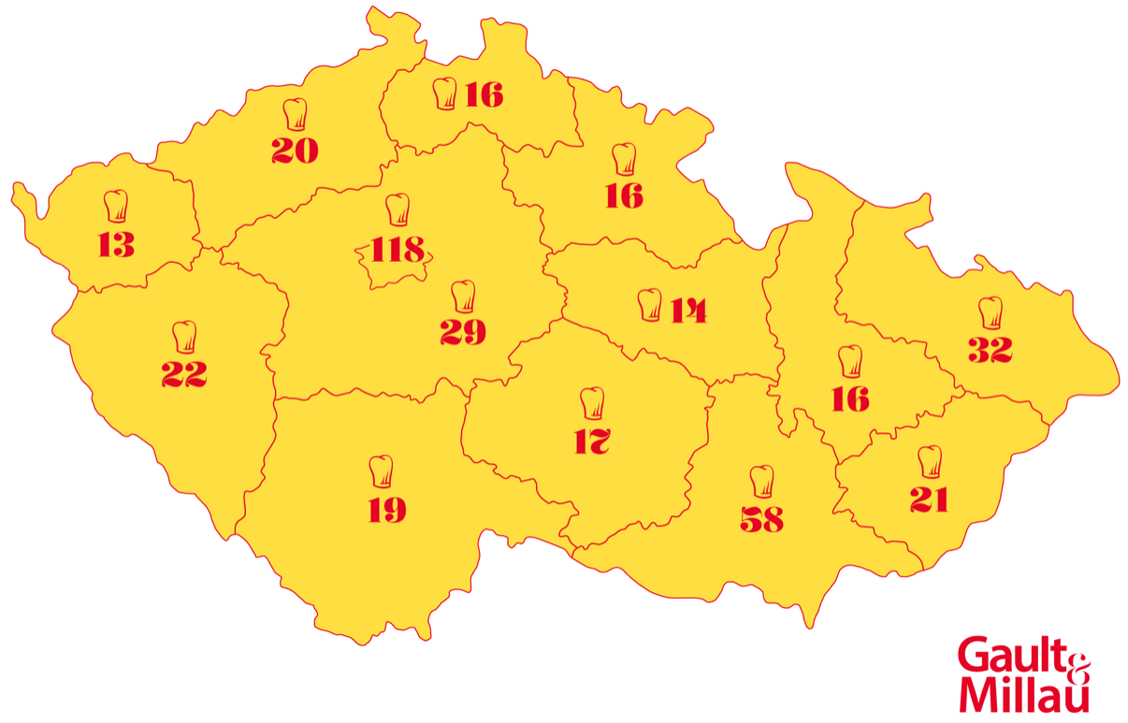

Number of classified restaurants by regions of the Czech Republic

*"I am very happy to see how many restaurants across the Czech Republic have achieved the toques. There are many evaluation criteria and just one toque is a really big achievement. Czech gastronomy has shown us how great it is, and at the international level,"* comments **Michaela Židlický, Chief of Guide of the Czech Gault&Millau**.

However, Gault&Millau does not only give awards to restaurants, but also to those who prepare the delicacies there. These are the following three categories:

**Chef of the Year** - Awarded to the chef who has distinguished himself by the originality and personality of his cuisine. The award is only given if the result of the ivestigators' evaluation is unanimous. This year, **Jan Knedla from Restaurant Papilio** was selected. According to the investigators, Knedla's talent and diligence is evident in every detail of his dishes, which are influenced mainly by French cuisine and technique. Its application to Czech ingredients is not only innovative, but also inspiring. Papilio cuisine is a link between the present and the future direction that brings Czech cuisine even more to the international level. Gault&Millau wants to support these trends.

**Great Chef of Tomorrow** - Awarded to chefs who are on the rise according to the criteria and repeated evaluation by Gault&Millau investigators, or who improve between seasons and receive an extra toque. This award for 2025 goes to **Otto Vasak from Restaurant Essens**. According to the investigators, he took on a difficult task when, outside the main gastronomic scene, he began to showcase culinary creations that are equal to even the most demanding gastronomic regions. He is not afraid to experiment and does not succumb to the currant culinary trends. Thanks to this, this chef working in the South Moravian Region is a promise for Czech gastronomy in the future.

**Young Talent of the Year** - This award goes to a chef with a score of 11 points or more who is under the age 35. The Gault&Millau investigators selected **Barbora Šimůnková from the LEAF restaurant** for this award. Šimůnková builds her cuisine mainly on vegetables, knows all her suppliers personally and travels around the Czech Republic to select the ingredients herself. In her restaurant, you will not find ingredients bought in wholesalers. She takes a holistic view of food origin, human health and possible dietary or tolerance restrictions, to which is able to adapt her cuisine.

In addition to these three special awards, there is a fourth one called **POP of the Year**. It is awarded to a specific place, where the inspectors appreciate the creativity of the concept, the quality of the food and drink or the overall contribution to the region. The 2025 POP of the Year is **EGGO BreakFeast Bistro**, which goes far beyond its doors. Not only does the bistro currently operate as a pop-up in Prague's Kro Karlín bistro, where it contributes to the menu, but it also regularly hosts chefs from other restaurants in its space, bringing exceptional opportunities to sample other cuisines from street food to fine dining, including wine pairings. This modern and progressive approach enriches the place itself, its guests and the region.

**About Gault&Millau**

The French Gastronomic Guide was founded by journalists Henri Gault and Christian Millau in the 1960s as a reaction to the previously rigid evaluation rules of other guides. They created a flexible rating system based on a combination of awarding the symbol of the chef's hat ('toque') and points. They defined the culinary tenets of the so-called 'Nouvelle Cuisine'. Their approach and work put them on the cover of the prestigious Time magazine in 1980 and their system helped to discover many gastronomic talents. Gault&Millau is currently present in France, Germany, Austria, Switzerland, Belgium, Luxembourg, the Netherlands, the Czech Republic, Croatia, Serbia, Slovenia, Turkey, Georgia, the United Arab Emirates, Japan and will eventually expand to Slovakia and Hungary.

**Media contact:**

Michael Lapčík

Michael.lapcik@gault-millau.cz

+420 725 774 272